2152118 史君宝 数据库原理 第二次作业

1. **第一题：**

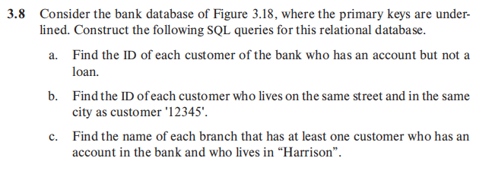

表3.18：

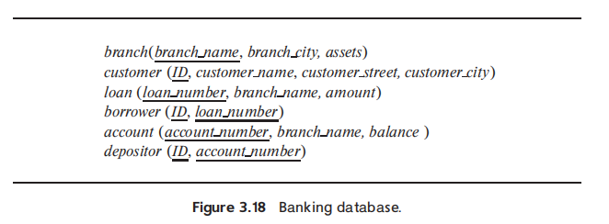

解答：

(a) 查找银行中每个有帐户但没有贷款的ID。

select ID from depositor EXCEPT select ID from borrower;

(b) 查找与客户'12345'住在同一街道和同一城市的每个客户的ID。

select F.ID from customer as F, customer as S where F.customer_street = S.customer_street and F.customer_city = S.customer_city and S.ID = 12345;

(c)找出至少有一个客户在银行有账户并且住在“Harrison”的每个分行的名称。

select distinct branch_name from account, depositor, customer where customer.ID = depositor.ID and depositor.account_number = account.account_number and customer_city = 'Harrison'

1. **第二题：**

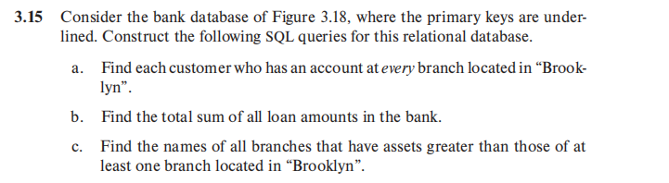

表3.18：



(a)找到在位于“Brooklyn”的每个分行拥有帐户的每个客户。

select distinct customer.ID from customer,depositor,account,branch where customer.ID = depositor.ID and depositor.account_number = account.account_number and account.branch_name = branch.branch_name and branch_city = “Brooklyn”;

(b)找出银行中所有贷款金额的总和。

select sum(amount) from account;

(c)找出资产大于至少一个位于“布鲁克林”的分支机构的所有分支机构的名称。

select branch_name from branch where assets > (select MIN(assets) from branch where branch_city = 'Brooklyn');

1. **第三题：**

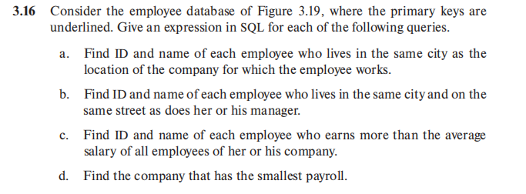

图3.19：



(a)查找每个员工的ID和姓名，这些员工居住在与其工作的公司所在的城市。

Select ID, person_name from employee join works ON employee.ID = works.ID

join company ON works.company_name = company.company_name where employee.city = company.city;

(b)找到每个与她或他的经理住在同一城市和同一街道的员工的ID和名字。

select ID, person_name from employee join manages on employee.manager_id = manages.ID as A, employee as B where A.city = B.city and A.street = B.street;

(c)找出每个收入超过公司所有员工平均工资的员工的ID和名字。

SELECT e.ID, e.person_name

FROM employee e

JOIN works w ON e.ID = w.ID

JOIN company c ON w.company_name = c.company_name

WHERE w.salary > (

SELECT AVG(w2.salary)

FROM works w2

WHERE w2.company_name = w.company_name

);

(d)找到工资最少的公司。

select company.company_name from company join works on company.company_name = works.company_name group by company.company_name having MIN(works.salary) = (select MIN(w2.salary) from works w2);